Template for IAPRI 2024 Papers

Name Surname ¹ and Name Surname ^{2*}

¹ Department, University or Institute, Country
² Department, University or Institute, Country

*Corresponding author. Email: i.name@institute.edu
Abstract: All papers submitted for IAPRI 2024 must use this template. All details regarding formatting are stated below. Included are examples of how to present equations, figures, tables, and references. The abstract must offer a concise summary of the paper and be between 200 and 300 words (no less than 200 words).
Keywords: keywords in lower case, separated by commas and finish with a full-stop.

1 Introduction
This template contains the styles and formatting required IAPRI 2024 papers. The paper must be A4, use single column format and have the following margins: top 3cm, left/right/bottom 2.5cm. All text, figures and tables are to be kept within the margins.
The font sizes and styles used in the paper are: 1) Title: Times New Roman 18 bold, sentence style, spacing before 12 pt; 2) Headings: Times New Roman 12 bold, spacing before and after 6 pt; 3) Sub-headings: Times New Roman 11 bold, spacing before and after 6 pt; 4) Body text: Times New Roman 10, justified, spacing after 6 pt.
The title of the paper must be centre justified and capitalised (e.g. This is How a Paper Title Must be Typed).
The Conference header must be shown on the first page only. Do not include page numbers, they will be added later.

2 Document structure
The paper must be arranged in the following order: title, authors, affiliation, corresponding author, abstract, keywords, introduction, body of the paper (subdivided using suitable headings as required), conclusions, acknowledgements and references. The authors' names are given as first name written in full followed by middle initial(s) and last name written in full. References must be numbered consecutively in the text with Arabic numerals included in square parenthesis. An example of the in text referencing format is as follows: Work by Lee and Bennett [1] was supported by Jones [2] but later rejected by Harman et al. [4].

2.1 Equations
Equations must be centred on the page and numbered consecutively as they appear in the text using Arabic numerals in parenthesis. The equation numbering must be right justified. Within the test equations must be referred to by their numbers only, e.g. an example equation is given in (1) below.
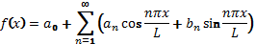 (1)

2.2 Tables and Figures
Diagrams, graphs and photographs are all labelled as figures. The figures must be numbered consecutively with Arabic numerals in the order in they are mentioned in the text. The word ‘Figure’ must be spelt out in full in the text and must be capitalised, i.e. Figure 1, Figure 2, etc.. The figure, figure number and caption must be centred on the page with the caption written below the figure, as shown in Figure 1.
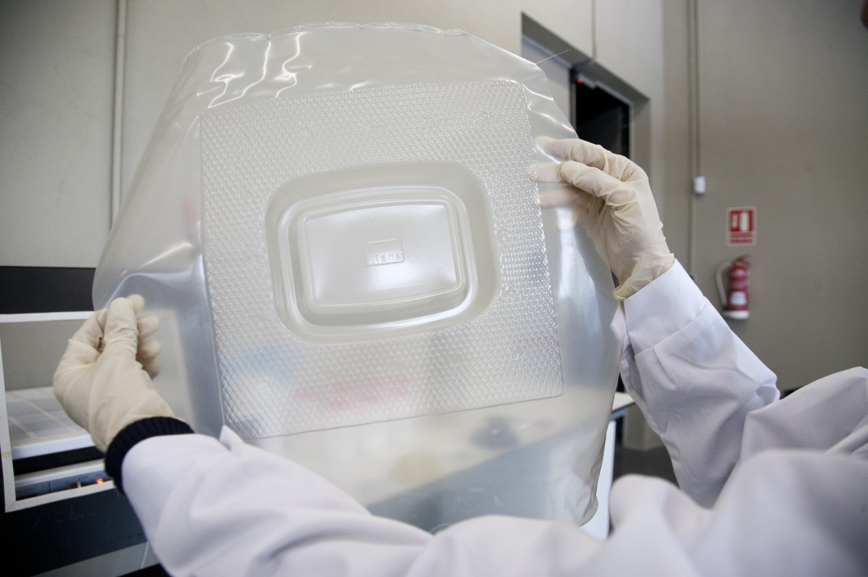
Figure 1: Thermoformed tray sample.
Each table must be located as close as possible to their first reference in the text. Tables must be consecutively numbered with Arabic numerals. The table, table number and caption must be centred on the page with the caption written above the table, as shown in Table 1.
Table 1: Properties of the material samples.
Sample type | Equivalent viscous damping ratio, ζ | Thickness x width [mm] | Initial length [mm]
Steel | 0.8% | 1 x 25 | 185
Aluminium | 1.25% | 3 x 25 | 315
Acrylic | 6.30% | 4.5 x 25 | 250
Carbon fibre | 2.50% | 3 x 25 | 325

3 Conclusions
Particular care should be taken in this section the real value of a paper is reflected in the nature, soundness and clarity of the conclusions.

Acknowledgements
If appropriate, include a short paragraph acknowledging any special support provided by a third party.

References
- References must be listed in the order they appear in the text.
- Font size and style for references: Times New Roman 10, spacing after 6 pt, hanging 0.75cm.
- Journal Example: J.J. Sutherland. C.S. Lamb and P.R. Jackson, 2006, “An experimental on the clarity of ink text on paperboard samples", Journal of Packaging, vol. 173, no. 2, pp. 226-233.
- Conference Example: A.B. Johns, 2007, “Monitoring the decay of paperboard samples", Proceedings of a Conference, Melbourne, Australia, Nov. 18-20, pp. 150-159.
- Book Example: R.A. Smith, 2005, Mechanical Vibrations, 3rd Ed., Prentice Hall, Singapore, pp. 235-242.
- Chapter in Book with Editors/Multiple Authors Example: S. Haywood 2012, “Introduction: The LMS filter”, In: S. Haywood and B. Wilwood (eds), Least-Mean-Squares Adaptive Filters, John Wiley & Sons, New York, pp. 57-68.

